**Review**

* Set up a review just after a milestone so that attention is focused on future tasks.
* A review should be conducted with other people – for example, your partner, work colleague or tutor – so that some external scrutiny can take place.
* Working without an agenda only leads to problems, so be sure to have a workable set of headings – not too many and not too obscure.
* Look at items such as tasks completed, measurements of progress and setbacks.
* Reflect on the project aims and consider the remaining phases and tasks.
* Use the schedule as the guide and be prepared to revise the plan.
* Be ruthless in selecting the project tasks so don’t keep any ‘nice to have, but not strictly necessary’ items.

How was my project management?

Your plan and log should help with questions such as:

* What did I do?
* What worked well and what did not work out too well?
* What would I do differently next time?
* How would I do it?

Regarding the technical aspects, give a positive rationale for your chosen evaluation or solutions, also indicate any false starts or particular difficulties. What have these processes taught you about specifying and designing a problem solution? What demands were placed on you and how did you use your project management skills when tackling the technical tasks?

Regarding the management and self-evaluation aspects, your tutor will be looking for your reflections on your work. They will want to know:

* what you learnt from comparing what you originally planned to do with what you actually did
* how you had to replan
* how much effort you made
* what personal benefits you gained through doing the project.

It is quite possible to get a high mark for a project even if you do not fully succeed in what you hoped to do, provided that you:

* give a good analysis of what went wrong
* reflect on your own performance
* suggest how things could be improved if you were to do the project, or a similar project, again.

Project lifecycle structures the 4 main project activities (Analysis, Design, Implementation, Evaluation). Needs to support efficient and effective progress towards project outcome. AN effective project solves the problem it aimed to solve,

Legal/ethical issues with encouraging consumption of out of date products. Data protection gdpr. Accessibility legislation

Requirements are my own to determine, no stakeholders other than potential users of application.

Risks are that I will spend to long trying to develop new skills, and not enough time delivering projects

**TMA02 –** forgot delete, need to adjust plan. Also need to read about what responsive actually means!

Haven’t considered research for food safety info.

Sources

<https://www-safaribooksonline-com.libezproxy.open.ac.uk/library/view/sams-teach-yourself/9780135167069/part04.xhtml>

<https://www-safaribooksonline-com.libezproxy.open.ac.uk/library/view/front-end-reactive-architectures/9781484231807/A446957_1_En_2_Chapter.html>

<https://www-safaribooksonline-com.libezproxy.open.ac.uk/library/view/react-and-react/9781789346794/>

https://www-safaribooksonline-com.libezproxy.open.ac.uk/library/view/jump-start-responsive/9781492020615/

<https://www.fusioncharts.com/resources/developers/js-frontend-frameworks-comparison>

<https://vuejs.org/>

<https://reactjs.org/>

<https://www-safaribooksonline-com.libezproxy.open.ac.uk/library/view/bootstrap-4/9781788397315/>

video: <https://www-safaribooksonline-com.libezproxy.open.ac.uk/videos/responsive-web-design/9780672337734>

<https://hackr.io/blog/10-best-javascript-frameworks-2019>

**React**

https://app.pluralsight.com/player?course=react-fundamentals-update&author=liam-mclennan&name=211de11a-16ae-4cdb-95ac-9909a703d20f&clip=0&mode=live

React pros and cons

Pure rendering and event handling

Purely concerned with UI, only for components

Vanilla js

Not a framework, need to find own components for routing, forms etc

Harder than others as a lot of plain JS, no directives to help like angular and Vue

https://app.pluralsight.com/player?course=vuejs-big-picture&author=daniel-stern&name=a9d0eb37-1a2c-413f-a37c-7a9ef277f353&clip=0&mode=live

**Vue**

Good for small apps

Vue-cli can be used as local server for running locally

Familiar directives to Angular, might be less steep learning curve

Also doesn’t do routing (need Vue-Router library)

Angular and React are bigger code sizes

Newer so fewer resources, might be tricky if I get stuck

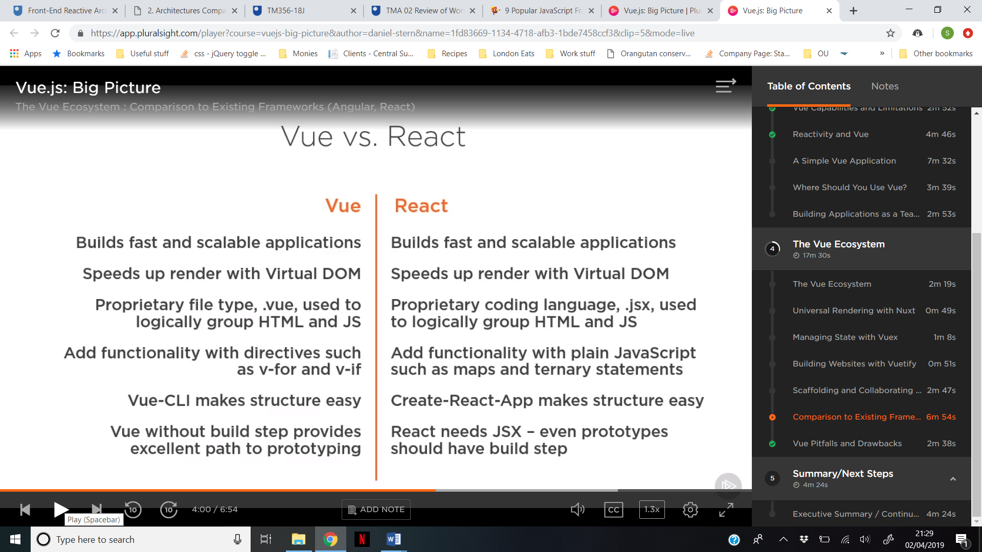

Legal implications of using 3rd party API

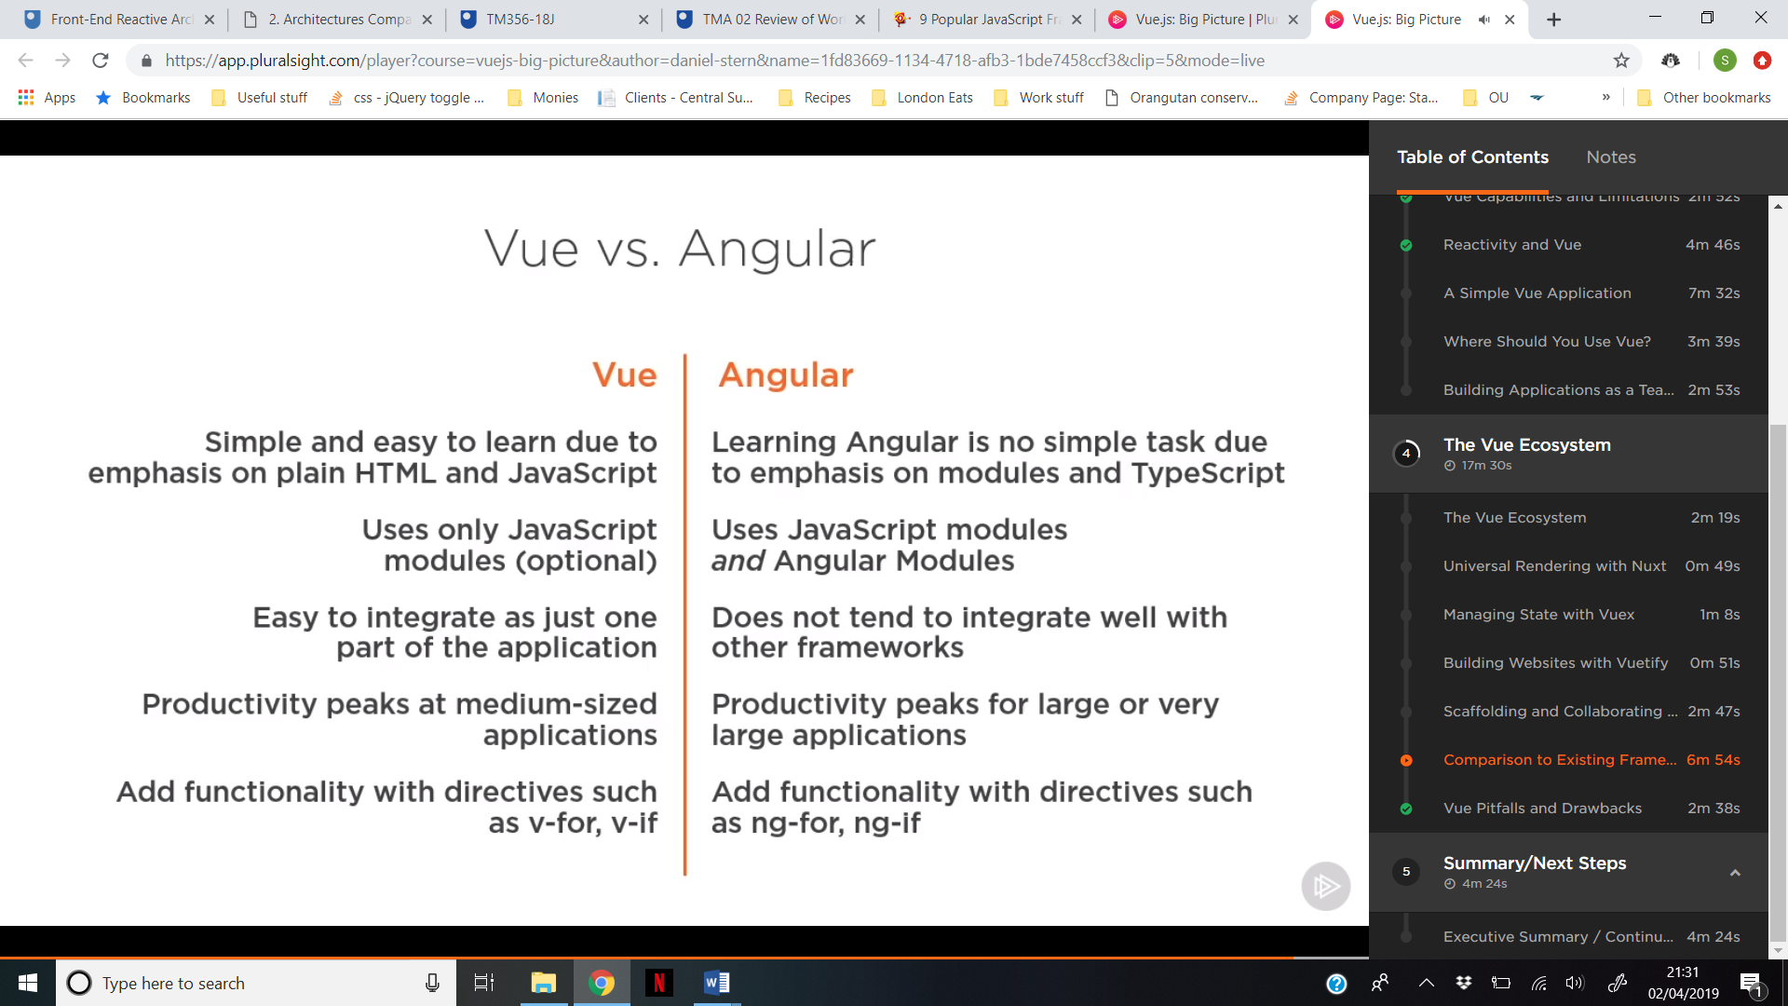

Ethical issues – requirements gathering data protection, consent form